Living with a disability: Emma Fitzgearld may not be able to walk, but that has not stopped her from living life to the fullest.

Emma Fitzgearld was diagnosed with Kyphosis as a teenager which is a disorder that causes a painful hunching of the back and a curved spine. Types of Kyphosis can appear in teens because of malformation of the spine or a wedging of the spinal bones, according to Mayo Clinic. Kyphosis can cause severe pain, a visible hump on the back, numbness in the legs, and shortness of breath.

At 16 years old, Fitzgearld received a spinal fusion surgery to help straighten her spine and relieve the pain of the Kyphosis. The day after the surgery, she was able to move around and appeared to recover just fine. However, by the second day, she could no longer move her legs. Surgeons believe the surgery led to a “spinal stroke” but Fitzgearld notes that “they still to this day don’t know why it happened.” She has been paralyzed from the waist down ever since.
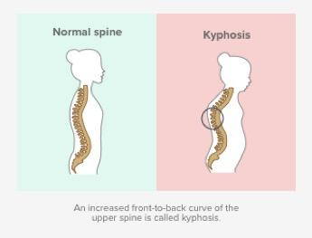
“I never heard the words you will never walk again,’” Fitzgearld said. Although the doctors could have potentially said those words behind her back, she said she never heard it directly from them, which gave her hope that there was a chance that she would be able to walk again one day.

Lauren Turk, a registered nurse at Texas Health Clearfork, spoke of how the odds of being able to walk again after experiencing paralysis depend on the location and severity of what was
The image above shows the difference between what a normal
spine looks like compared to Kyphosis. (Sourced from Huffman
Clinic)

affected.

“It depends on the type of paralysis,” Turk said. “It depends on what area of their spine was affected. The higher up that they were affected, the less likely they’ll regain mobility. But the lower down, they have a much better chance of being able to walk again and regain all their mobility.”

Throughout Turk’s career in the medical field, she has not personally seen a spinal surgery that led to a person becoming paralyzed; and that surgical outcome is considered rare because the technology that exists nowadays ensures that the surgery is as safe as possible. However, there are still risks associated with the surgery.

“Risks could be bleeding or infection,” Turk said. “There’s the possibility of paralysis and even death. It’s unlikely that any of those will happen, but those are risks.”

Although Fitzgearld knew the high risks of the spinal surgery going into it, she said she never once thought that she would become paralyzed and that never being able to walk again would become her reality. It seemed so far out of the realm of possibilities for the rest of her life.

“The doctors have so many theories as to why this happened because the surgery went perfectly, according to the physician,” Fitzgearld said. “There was nothing wrong during the actual surgery.”

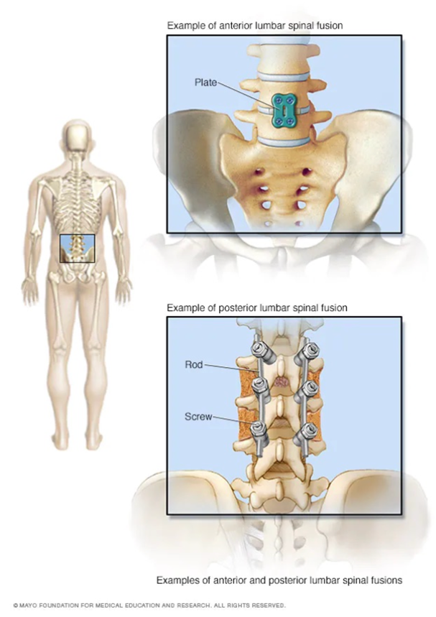
Fitzgearld ultimately decided not to sue the surgeon for what happened to her. There was no way to prove that a mistake had been made during the surgery and Fitzgearld didn’t see a point in ruining a surgeon’s career over something that couldn’t be proved.

The surgeon still holds guilt to this day and blames himself for what happened to her. Fitzgerald attests to the surgeon’s constant visits to her in the hospital and genuine guilt and empathy towards her as contributing factors to why she and her family ultimately decided not to sue the physician.

“It just wasn’t worth it to me because I’m like ‘What’s money going to do? It’s not going to give me my legs back,’” Fitzgearld said. “That was just never a priority for my family because we were just trying to deal with the emotions of the situation.”

The image above shows fusion options for the
lower back. (Sourced from Mayo Clinic)

Not being told that she would never be able to walk again gave Fitzgearld and her family hope that it was possible. She attended physical therapy for three years after the surgery. However, her insurance only covered around six visits every year when the physical therapists recommended therapy sessions three times per week. Although she fully committed to physical therapy despite the expense, she said the physical therapists eventually stopped working with her completely because they claimed she was “too good.”

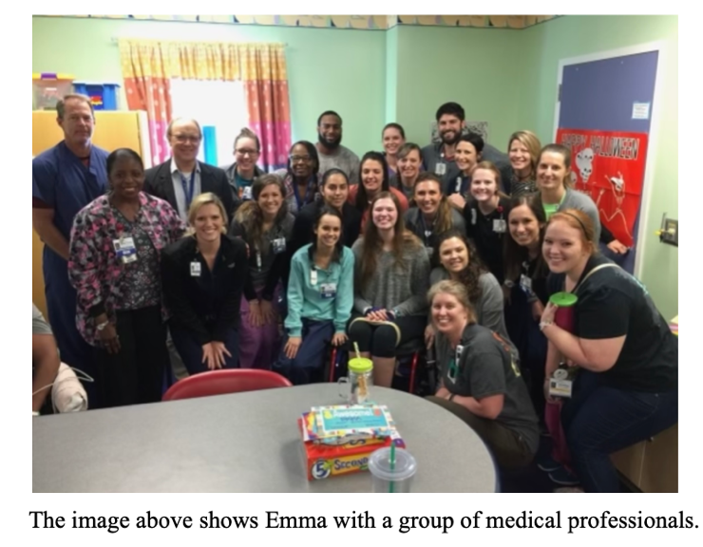
Despite being told that she was “too good,” Fitzgerald saw the reality of the situation which was that she still was not able to walk. She believes the physical therapist’s primary goal with therapy was to gain as much independence as possible to function successfully within her everyday life.

Turk noted that at her previous job, there were physical therapists who dismissed their patients.

“Physical therapists said because of where the injury was, there was no probability they would gain mobility so that person ended up in a long-term facility,” Turk said.

Although physical therapy helped Fitzgearld become independent and gave her the tools to be able to live on her own, there was always a lingering thought for her and her family of if she continued physical therapy, maybe she could have eventually been able to walk again.

“I stopped physical therapy and that was kind of like raining on my family because now it feels like physical therapists are like ‘Oh okay, well there’s nothing else we can do for you,’” Fitzgearld said. “So, it hurt my family because they were like ‘Well we thought you might be able to walk again and now it feels like they’re giving up on us.’”

Becoming paralyzed ultimately affected Fitzgearld’s family more than it affected her because of how difficult it was for them to witness her in those circumstances and simply being unable to change it or make it better for her.

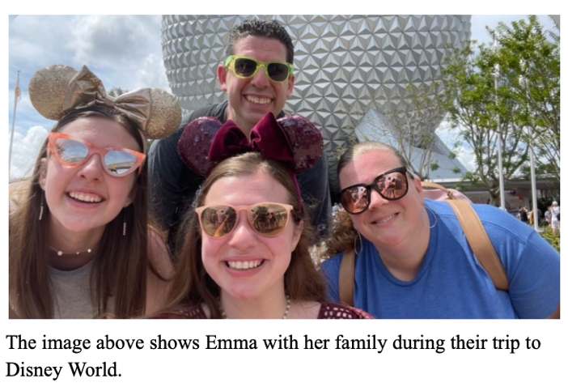
“It’s another thing when you can’t do anything about it and you’re watching your daughter go through something at 16 that she should never have to go through,” Fitzgearld said, adding that her family had to find a way to be there for her while also processing their own emotions about what happened.

After becoming paralyzed, Fitzgearld developed severe anxiety to the point where she would become physically sick because of her fears of whether the places she went to would be accessible or not. Those fears would only grow when someone would invite her to a place that she had never been to before.
“I’d be like ‘Oh gosh I don’t know if it’s accessible,’” Fitzgearld said. “Are they going to have stairs in their house? Is their house going to be accessible on the inside? Do they have an accessible bathroom?’ It’s just everything I must think of when people invite me somewhere new.”

The United States is considered one of the most accessible countries in the world, however, 25.5 million Americans have travel-limiting disabilities, according to the U.S. Department of Transportation. Fitzgearld considers houses to be among the least accessible places.

“There are places that I won’t go to because I’m too scared that it’s going to be inaccessible for me because it’s happened before,” Fitzgearld said. “It’s not like ‘oh just in case.’ I’ve gotten to places where I’m like, there are flights of stairs every way into this house. A lot of houses, the front door is not wide. Like I haven’t even been able to get in the front door of some houses because it's narrow.”

The Americans with Disabilities Act was passed nearly 32 years ago, but there are still widespread barriers for those with disabilities and limited functioning. According to a study in 2020, 65% of curb ramps and 48% of sidewalks are not accessible to people with disabilities.

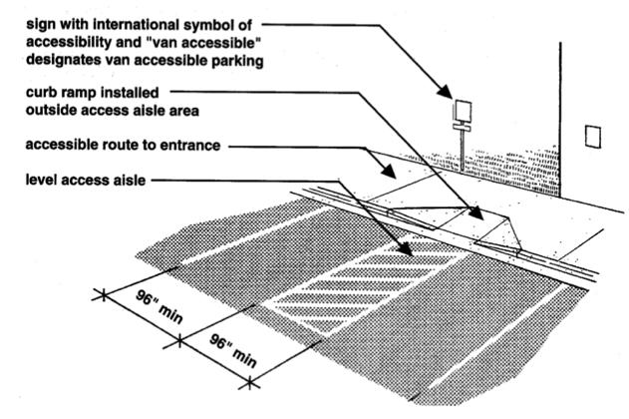

“It is the law that public places, if they are a certain square foot, they have to have handicapped spots outside and an accessible bathroom and then a big enough doorway and a ramp,” Fitzgearld said. “But then some places were grandfathered in because they were built before that law was passed so then they don’t have to abide by all those laws. That’s really frustrating because then I’m like ‘just because
they were built in 1989 and the law passed in 1990 like you should still make some modifications.”
The image above is a diagram that shows the
wheelchair accessible route when it comes to
parking. (Sourced from Tuesday Talk with Alex
on WordPress)

Fitzgearld spoke of how she has always enjoyed attending concerts, but they can be difficult to navigate because the handicapped section is not always elevated so when the people in front of the section stand up, it creates a complete blockade. While some concert workers would move her up closer to the stage where she could see, there have been other instances where she was forced to stay where she was even though she couldn’t see anything yet had paid the same amount of money as everyone else for concert tickets.

When it comes to traveling, airplanes are certainly not among the most accessible, but Fitzgearld continues to travel despite it. Concerns regarding travel stem less from the airplane itself and more from the risk of potentially having her wheelchair become damaged as they are costly to replace.

The Air Carrier Access Act is a law that protects disabled passengers from discrimination by airlines. However, the American Disabilities Act of 1990 does not regulate discrimination regarding air travel. A 2021 survey found that 43% of wheelchair customers refuse to fly on an airplane, in large part because they have concerns and a fear of their wheelchair becoming damaged during the flight, according to Disability Horizons. 60% of the people in the survey had their wheelchairs damaged when flying.

Fitzgearld is a wheelchair consumer who has fears and concerns about her wheelchair becoming damaged when traveling. She will tell airport workers at least three or four times to be careful and cautious with her wheelchair when putting it underneath the plane with the rest of the luggage as she has heard horror stories of wheelchairs becoming damaged or broken during the flight. Even with communicating her fears to the airport workers, it doesn’t always make a difference as there have been times, she has witnessed her wheelchair toppling over and falling to the ground when being removed from underneath the plane by baggage handlers.

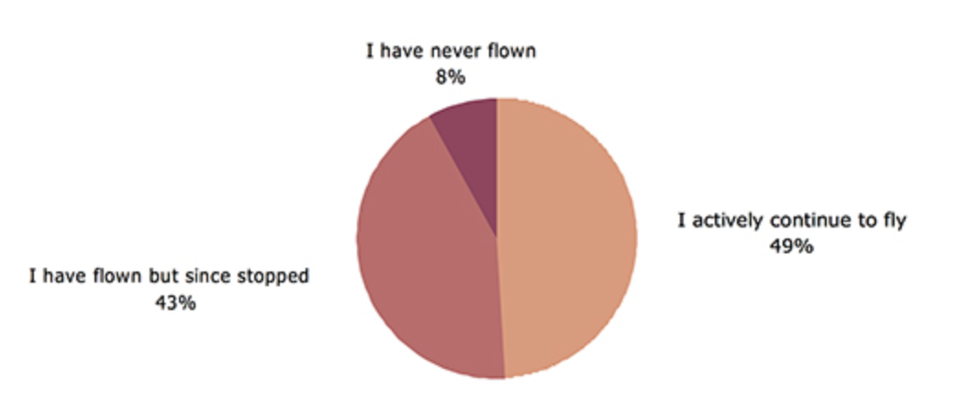

Although she gets to be the first person on the airplane when traveling, she is always the last person to get off the plane.

“I go to the front of the line,” Fitzgearld said.

The image above is a pie chart that shows the percentages of wheelchair
users who have never flown, who have flown but since stopped and who
have actively continued to fly. (Sourced from Disability Horizons)

“So, I get on the plane first and I have to transfer into what they call an aisle chair so it’s like a really tiny wheelchair. They put me in a tiny chair and strap me up and they’re like ‘We cannot have any liabilities; we cannot have you falling.’”

Many things that once seemed unchallenging for Fitzgearld or are unchallenging for those who aren’t living with a disability, had suddenly become a hurdle that she had to overcome. Navigating through airport security was a new challenge and added pressure for her while traveling.

“Security at airports is so uncomfortable because they have to pat down every square inch of my body because I can’t fit through the security thing,” Fitzgearld said, adding that she once had to wait 15 minutes at airport security until a woman was available to do the pat down because she was not comfortable with a man doing it.

Her experiences in public places have not only been affected by inaccessibility but from judgment and questioning from people regarding her disability.

“I’ve definitely been treated differently in public places and it’s typically older people that I’ve noticed,” Fitzgearld said. “I’ve had someone come up to me and be like ‘Oh so are you just using the wheelchair as an excuse now?’ And I was like ‘Who are you? I don’t know why I would do this on purpose’ and she was like ‘Oh I didn’t know if young people were starting to try and make up excuses to be lazy.’”

Encounters such as that one have happened far too often in Fitzgearld’s world as many people are not used to seeing a younger person in a wheelchair with a disability. While being paralyzed has limited her physical abilities, it has also affected her mental well-being.
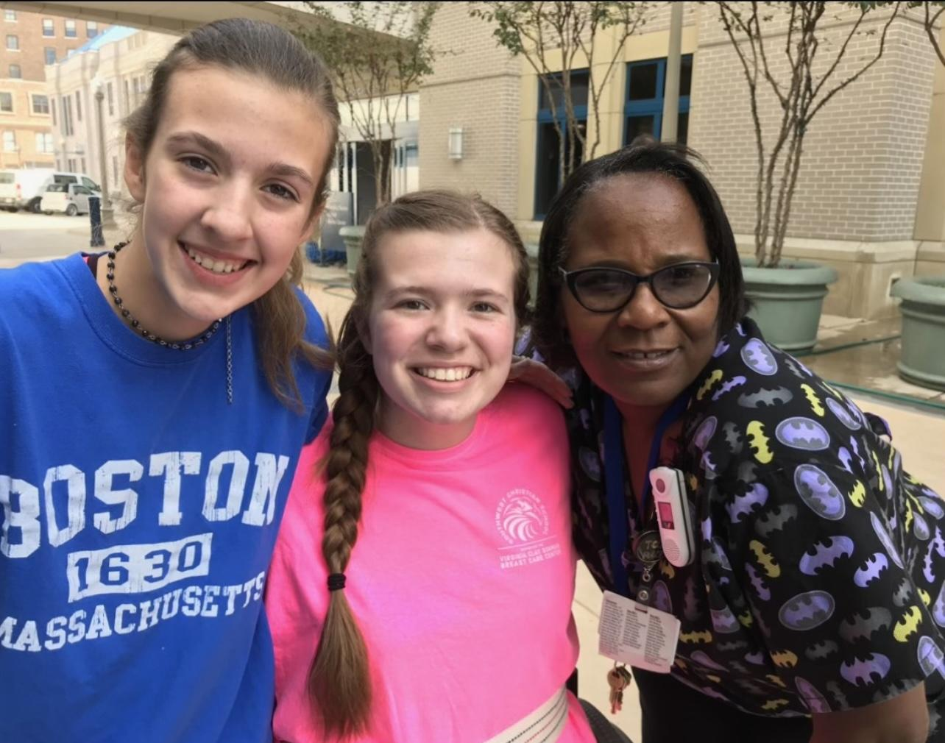
“It definitely took a toll on my relationship with God and my mental health,” Fitzgearld said. “And when I got to college, it was scary because yes, I’m in the same city as my family, but just living on my own was terrifying and trying to figure out this campus and where all the ramps are. It was terrifying.”

The image above shows Emma with
a nurse and friend.
Fitzgearld spoke of how it took her nearly a year after her surgery to even be able to open her Bible again because of her anger and simply not being able to understand why God would put her through such a devastating situation.

People in high school would be like, ‘Your senior speech is going to be sick like you have so many things you’ve been through,’” Fitzgearld said. “And they’re like ‘I don’t have anything to write about, that sucks’ and I’m like ‘I wish I didn’t have anything to write about.’”

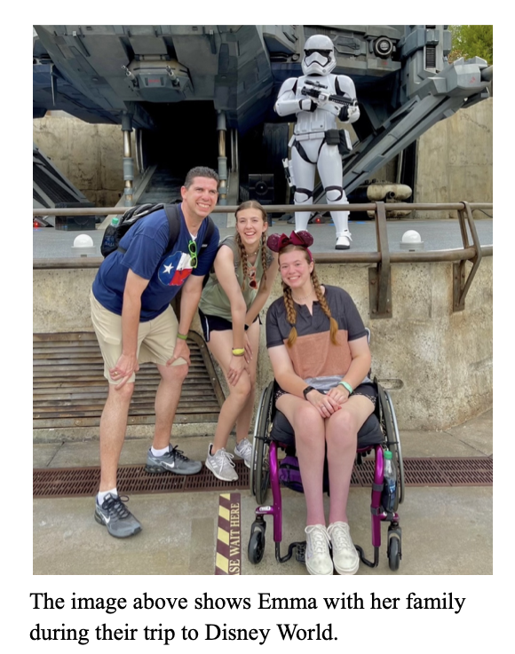
Despite her circumstances, staying positive and leaning on her faith is what helped Fitzgearld navigate her new ‘normal.’ Losing her father this past year who was the one that Fitzgearld said, “always held everything together,” is yet another struggle that has tested her mentally, but it has ultimately built up her strength. Hearing other people complain about things that are so minuscule in comparison to the personal struggles that she has had to face used to bother her, but Fitzgearld has chosen to have empathy for everyone no matter what.

“Everyone has their own struggles,” Fitzgearld said. “Just because I have hard ones doesn’t mean that someone else doesn’t have what’s hard for them. I just want to be there for everyone no matter what they’re going through, no matter how small or how big. I’ve been through enough to where it’s like, anything can hurt. It’s not just big things.”

Fitzgearld wants to use what happened to her to help other people who may be going through something similar which is why she created a Youtube channel where she openly speaks about how she navigates the world in a wheelchair.

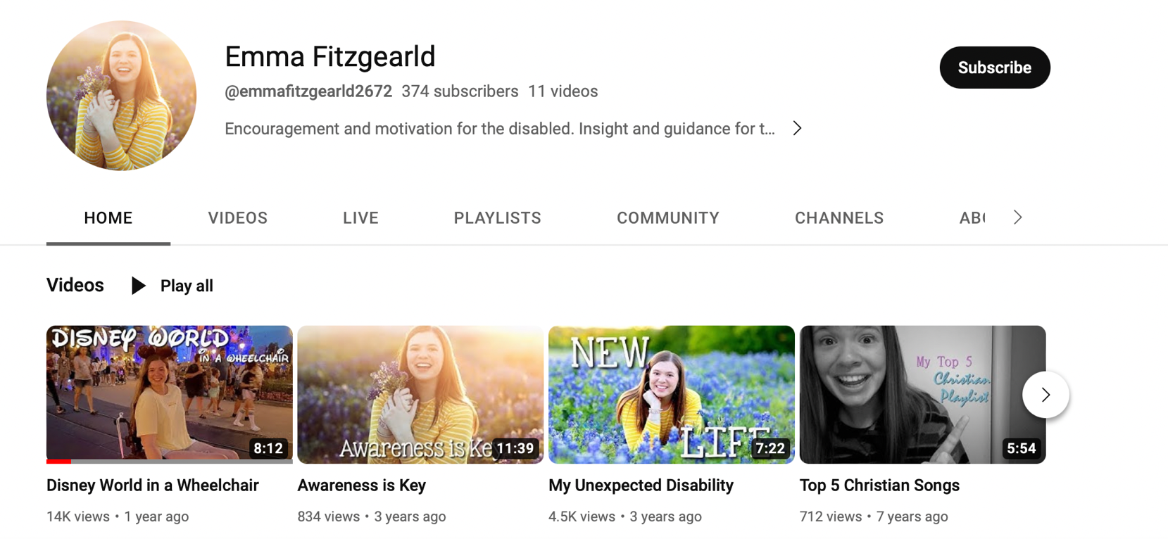
https://www.youtube.com/watch?v=2Wa_HMHf3y0&t=1s

“I just want to be treated like everyone else,” Fitzgearld said. “Somebody else next to me could be going through something a million times worse and they look fine. Like just because I’m visibly not able to walk, it doesn’t mean that I’m not doing okay. I’m doing fine.”

Fitzgearld has found a home away from home at TCU where she has made supportive friends who will stand up for her and who know her story. Regarding accessibility, she spoke of how the TCU campus is much more accessible than she was expecting it to be and that the university “has been amazing” pertaining to her disability. Fitzgearld is currently a senior who is majoring in speech pathology, which she discovered during her time at the hospital after her surgery. There she witnessed speech therapists work with their patients with speech impairments.

“I found speech therapy and I can work with either kids or adults if I want to, and I love people and the art of communication,” Fitzgearld said. “Just being able to talk to each other is so huge so I just really want to be there to help people who can’t express themselves.”

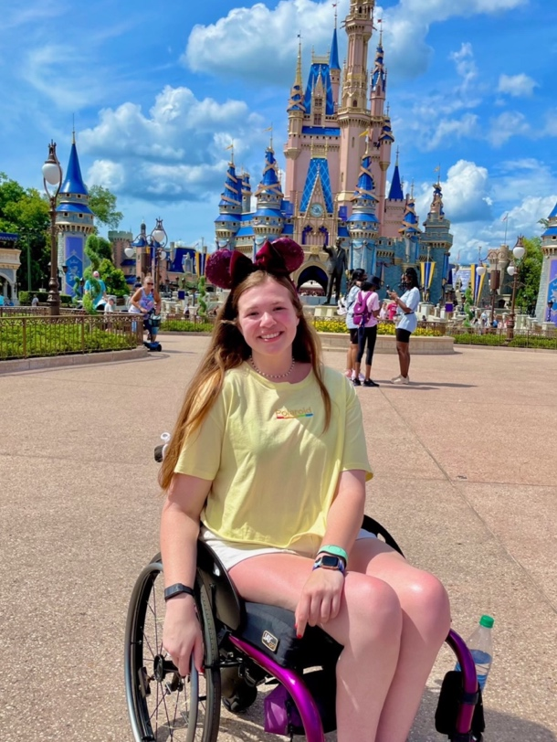
After years of adjusting to her circumstances, Fitzgearld is at a place of contentment with where she is now. She can fully function on her own with a disability and although she is not sure that she will ever be able to walk again, she will always hold on to hope. However, she has made peace with never being able to walk again.

“I just have to keep building myself up and be like ‘Everything is going to be okay,’” Fitzgearld said. “This is all happening for a reason.”
The image above shows Emma on a trip to Disney
World. (Photo courtesy of Emma Fitzgearld).

Link to the story on shorthand:
https://preview.shorthand.com/5R86Bvt1Mq00ko95

